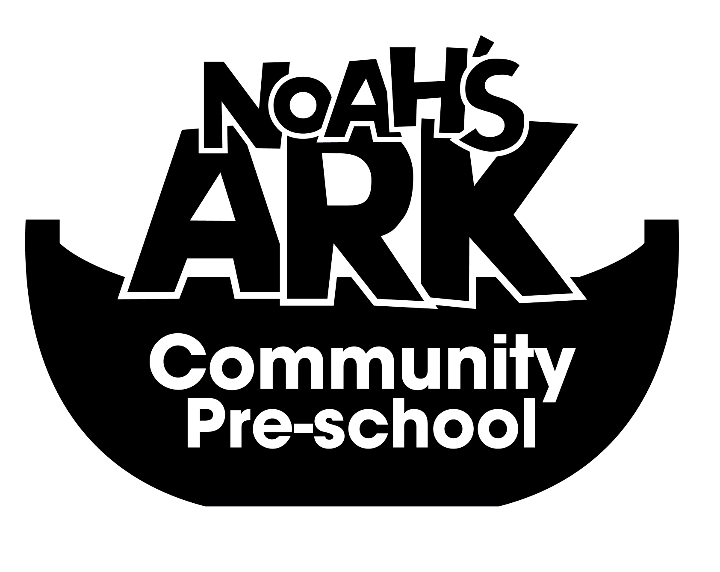

NOAHS ARK COMMUNITY PRE-SCHOOL

16. HYGIENE AND FOOD SAFETY

(September 2024)

- Children and adults will be encouraged to wash their hands after using the toilet. Soap and paper towels will be available.
- A large box of tissues will always be available to the children to blow and wipe their noses, after which washing their hands.
- Soiled tissues will be disposed of hygenically.
- Children will be encouraged to shield their mouths when coughing and sneezing. They will also be encouraged to wash their hands after.
- Children will be encouraged to wash their hands before snack time and after playing in the garden.
- All staff, volunteers and visitors will be made aware of how infections can be transmitted.

CLEANING

- Any spills of blood, vomit or excrement, will be wiped up with suitable paper and disinfectant spray and placed into a sealed bag and placed in the correct bin outside.
- Rubber gloves and plastic aprons must be used when cleaning spills of body fluids.
- Floors and other affected surfaces must be disinfected.
- Fabrics must be washed in hot water.
- Spare clean clothes must always be available in case of accidents.
- Plastic bags will be available to take the soiled clothes home in.
- All surfaces must be cleaned daily with an anti-bacterial cleaner.

FOOD

Food hygiene is all the steps we take to protect health and well being, safeguarding food from anything that can cause it harm, and ensuring it is fit for consumption. All members of staff are responsible for food safety.

The Pre-school has a moral and legal obligation to provide safe food under Food and Safety law. A written record of our system of safety procedures, reports and action plans must be kept, which is monitored by our food safety officer. This is a legal requirement under EC regulations. All staff preparing food must have at least a level 2 in food safety (See training policy) Volunteers and placements will have this cascaded down to them.

Staff must inform the Pre-school leader if they have a food borne illness, colds, cuts wounds, boils or ear infections. They must not prepare food in these instances. They must inform the setting if they have had an illness whilst abroad also. Aprons must be worn when preparing food. Food safe cleaners must be used, ie non-toxic and non-tainting.

- All adults will wash hands under running water before handling food and after using the toilet.
- No food preparation will be carried out by people suffering from any infectious or contagious illness or skin sore.
- Plastic gloves and aprons will be used by staff, when preparing and giving out food.
- Adults must not sneeze or cough over food.
- Different cloths must be used for kitchen and toilet areas, and for craft and washing up.
- All fruit and veg must be washed thoroughly before use..
- Tea towels will be kept clean and washed daily.
- All cooking utensils will be kept clean and stored in a dust free place.
- Cracked or chipped china will not be used.

This policy is reviewed annually
Date: 3rd September 2024
Signed on behalf of the Pre-School:
Position: Manager

