NOAHS ARK COMMUNITY PRE-SCHOOL

7. Safeguarding Children Policy

(1st September 2024)

This policy is in line with the London Child Protection Procedures www.londonscb.gov.uk “working together to safeguard children” (2023) and “what to do if you are worried a child is being abused” (2015).
This policy applies to all adults, including volunteers working in or on behalf of the Pre-School. Providers must be alert to any issues for concern in a child’s life, whether at home, or elsewhere.
Everyone working within our setting shares an objective to help keep children safe by contributing to:
* Providing a safe environment for children to learn and develop in.
* Identifying children who are suffering or likely to suffer significant harm, and take appropriate action with the aim of making sure they are kept safe both at home and at the Pre-school.

Manager at Preschool is Taira Darling

OUR DESIGNATED SAFEGUARDING LEAD (DSL) IS Taira Darling. The DEPUTY IS Saira Shoaib, Who have carried out the appropriate training and online training.

Noah’s Ark Community Pre-school is committed to Safeguarding and Promoting the welfare of all of its children. Every child’s welfare is of paramount importance.
We recognise that:
* Some children may be especially vulnerable to abuse
* Children who are abused or neglected may find it difficult to develop a sense of self worth and to view the world in a positive way. Whilst at the pre-school their behaviour may be challenging
* Children can be victims and perpetrators of abuse
* Children who harm others may have been abused themselves
* Allegations can be made against staff, however careful and safe our recruitment practices.

The legal framework for this work is:

Primary legislation

The children’s act 1989 - s 47
The protection of Children Act 1999
Data Protection Act 1998
The Children Act 2004 (Every Child Matters)
The children (NI) Order
The Children (Scotland) Order 1.2
This policy is in line with statutory guidance for settings, Keeping Child Safe in Education (2019), Early Years Foundation Stage (EYFS) (2021) Working Together to Safeguard Children (2018), London Child Protection Procedures (5th Edition), ‘What to do if You are Worried a Child is Being Abused’ 2015 and Ofsted guidance ‘Inspecting safeguarding in early years, education and skills’ (2016)
The statutory guidance Keeping Children Safe in Education 2016 is issued under Section 175 of the Education Act 2002, the Education (Independent School Standards) Regulations 2014 and the Education (Non-Maintained Special Schools) (England) Regulations 2011. Schools and colleges must have regard to this guidance when carrying out their duties to safeguard and promote the welfare of children. Other childcare providers may also find it helpful to refer to this guidance. Unless otherwise stated, ‘school’ in this guidance means all schools, whether maintained, non-maintained or independent, including academies and free schools, alternative provision academies and pupil referral units. ‘School’ includes maintained nursery schools.
All staff must read Part One of Keeping Children Safe in Education 2019 guidance and staff can find a copy in setting.

Everyone working in or for our setting service shares an objective to help keep children and young people safe by contributing to:
• providing a safe environment for children and young people to learn and develop in our setting, and
• identifying children and young people who are suffering or likely to suffer significant harm, and taking appropriate action with the aim of making sure they are kept safe both at home and in our setting

Guidance
What to do if you are worried a child is being abused (2004)
The framework for the Assessment of children in need and their families (2000)
Working together to safeguard children (revised 1999)
The common assessment framework 2005

Secondary Legislation
Sexual Offences Act (2003)
Criminal Justice and Court Services Act (2000)
Human Rights Act (1999)
Race Relations (Amendment) Act (2000)
Race Relations (Amendment) Act (1976) Regulations
Rehabilitation of Offenders Act 1974

Liaison with other bodies:
We work within the Local Safeguarding children’s board guidelines.
*We have a copy of the Local safeguarding children’s board guidelines available for staff and parents to see.
*We notify the registration authority (OFSTED) of any incident or accident and any changes in our arrangements which affect the well being of children.
*We have procedures for contacting the local authority on safeguarding children issues to ensure that it is easy in any emergency for the Pre-School and social services to work well together. Sometimes the police, the NSPCC or health visitor may be the first point of reference. If any of the above professionals advise that a referral for suspected child abuse be made, then we follow the agreed procedures. Dealing with concerns appropriately may prevent child abuse.
*If a report is to be made to the authorities, we act within the Local Safeguarding children’s board guidance in deciding whether we must inform the child’s parents at the same time.

PROVIDING A SAFE AND SUPPORTIVE ENVIRONMENT

SAFER RECRUITMENT AND SELECTION
The Pre-School pays full regard to ‘safeguarding Children and Safer Recruitment’ guidance. We ensure that all appropriate measures are applied in relation to everyone who works at the pre-school and who is therefore likely to be perceived by the children as a safe and trustworthy adult. This includes volunteers and staff employed by contractors. Safer recruitment practice includes scrutinising applicants, verifying identity and academic or vocational qualifications, obtaining professional references, checking previous employment history and ensuring that a candidate has the health and physical capacity for the job. Safer recruitment is also supported by our recruitment policy, and the pre-school leader has had specific safer recruitment training.

In line with statutory changes, underpinned by regulations, the following will apply:
*A DBS Enhanced Disclosure is obtained for all new members of staff/volunteers and all employees are checked with the Independent Safeguarding Authority. All staff are asked to be on the DBS update system and checks carried out during supervisions.
*The Pre-School is committed to keeping an up to date single central record detailing a range of checks carried out on our staff.
*All new appointments to our Pre-School who have lived outside the UK will be subject to additional checks as appropriate.
*Our Pre-School ensures that cover staff have undergone the necessary checks and will be made aware of this policy.
*Identity checks that must be carried out will be done so before the appointment is made, in partnership with the Local Authority (LA). policies and procedures are reviewed annually and this will provide information to the LA about us and about how the above duties have been discharged

SAFE PRACTICE
Our Pre-School will comply with the current guidance for safer working practice for those working with children.
http://www.dcsf.gov.uk/everychildmatters/resources-and-practice/G00311/ and ensure that information in this guidance regarding conduct, is known to all staff, visitors and volunteers who come into the Pre-School.
Safe working practice ensures that the child is safe and that all staff:
*Are responsible for their own actions and behaviour and should avoid any conduct which would lead any reasonable person to question their motivation and intentions.
*Work in an open and transparent way.
*Work with other colleagues where possible in situations that could be open to question.
*Discuss and/or take advice from the Pre-School’s management and/or the Designated Safeguarding Lead over any incident which may give rise for concern.
*Record any incidents or decisions made.
*Apply the same professional standards taking into account of diversity issues.
*Be aware of information sharing and confidentiality policies (Please read GDPR Privacy notice)
*Are aware that breaches of the law and other professional guidelines could result in criminal or disciplinary action being taken against them.

PLANNING
The layout of the room allows for constant supervision.

CURRICULUM
*We introduce key elements of safeguarding children into EYFS curriculum, so that children can develop an understanding of why and how to keep safe.
*We create within the Pre-School a culture of value and respect for the individual.
*We ensure that this is carried out in a way that is appropriate for the ages and stages of our children.

PARTNERSHIP WITH PARENTS
The Pre-School share a purpose with parents to educate and keep children safe from harm and to have their welfare promoted. We are committed to working with parents positively, openly and honestly. We ensure that all parents are treated with respect, dignity and courtesy. We respect parent’s rights to privacy and confidentiality and will not share sensitive information unless we have permission or it is necessary to do so in order to protect a child.
The Pre-School will, in most circumstances endeavor to discuss all concerns with parents about their children. However there may be exceptional circumstances when the Pre-school will discuss concerns with social services and/or police without parental knowledge (in accordance with the London Child Protection procedures). The pre-school will of course aim to maintain a positive relationship with all parents.
The Preschool will keep parents updated if a policy has been breached or needs enforcing.

PARTNERSHIP WITH OTHERS
Our Pre-School recognizes that it is essential to establish positive and effective working relationships with other agencies that are partners in Waltham Forest Safeguarding Children Board. There is a joint responsibility on all these agencies to share information to ensure the safeguarding of all children.

PRE-SCHOOL’S TRAINING AND STAFF INDUCTION
The DSL will undertake multi-agency safeguarding awareness and designated safeguarding lead training every 2/3 years. and annual refresher training.
All other members of staff, including voluntary staff will undertake appropriate induction training or safeguarding/child protection training to equip them to carry out their responsibilities for safeguarding effectively, which is kept updated every 6 months via the DSL, or another agency.
All staff (including cover and volunteers) are provided with the Pre-School’s safeguarding policy and informed of the Pre-School’s safeguarding arrangements on induction.

SUPPORT, ADVICE AND GUIDANCE FOR STAFF
Staff will be supported by the DSL and the deputy.
The DSL will be supported by the Pre-Schools management committee.
The DSL will know how to access the on-line London Child Protection Procedures. Staff will be asked to read Keeping Child Safe in Education (2019) which is government guidance.
If they’re not sure whether or not to make a referral to Social Services, you can contact the Child Protection team based at:
Juniper House,
221 Hoe Street,
Walthamstow, London E17 9PH

Referral and assessment team (Hoe Street) - 020 8496 7262 (reception)

Waltham Forest Children and young peoples 020 8496 2313

The LADO Gill Nash and Jennifer Knight 020 84963646 or 07791559789 (Gill), 07866314144 (Jennifer). Out of hours 02084963000

Safeguarding team

Point of contact for the child protection (enquiries that are not related to an allegation about a professional) 0208 4962310

Co-ordinators. There is always a CPC on duty

Police referral desk 0208 496 8279

SUPERVISION OF STAFF
To ensure staff are supported and developed to effectively carry out their role in protecting and safeguarding children in their care the settings practice is led by the nursery manager who is a qualified early years practitioner. This practitioner has the responsibility for ensuring that procedures are in place for all staff to receive regular formal supervision termly that will provide staff with an opportunity to review their performance, practice and development in working with the children and their families.
The supervision staff access will provide opportunities to:
• discuss any issues – particularly concerning children’s development or wellbeing, including child protection concerns
• identify solutions to address issues as they arise
• receive coaching to improve their personal effectiveness
EYFS 2021

RELATED PRE-SCHOOL POLICIES
Safeguarding covers more than the contribution to child protection in relation to individual children. It also encompasses issues such as a child’s health and safety, bullying and a range of other issues for example
Photography and images
To protect children, we will;
*Seek Parental consent
“Use only the child’s first name with an image

*Ensure children are appropriately dressed
*Encourage the child to tell us if they are worried about any photographs that are taken of them

*Have a policy regarding the use of mobile phones and cameras within the setting (See Computer, email & mobile phone Code of conduct policy)

Children missing from the Pre-School
The pre-school follows the safeguarding children missing from setting section of the London child protection procedures and will refer all cases of concern to the safeguarding team or contact the Family Information Service for guidance and support

Confidentiality
The Pre-School will operate with regard to “information sharing: Practitioner’s guide” HM Government 2006 www.ecm.gov.uk/deliveringservices/informationsharing and has a clear and explicit confidentiality policy.

CHILD INFORMATION
The pre-school ‘s record keeping policy for child welfare and child protection is consistent with the EYFS guidance, which is known to all staff
In order to keep children safe and provide appropriate care for them, the pre-school requires accurate and up to date information regarding:
*Names and contact details of persons with whom the child normally lives.
*Names and contact details of all persons with parental responsibility (if different from above).
*Emergency details (if different from above).
*Details of any persons authorized to collect the child from the Pre-School (if different from above).
*Any relevant court orders in place including those which affect any person’s access to the child (e.g. residence order, contact order, care order, injunctions etc).
*If the child is or has been subject to a child protection or care plan.
*Name and contact details of G.P.
*Any other factors which may impact on the safety and welfare of the child.
The Pre-School will collate, store and agree access to this information.
All child protection documents will be retained in a ‘Child Protection File’, separate from the child’s main file. The main file will clearly show an alert that a child protection file exists and the location of this. The child protection file will be locked away and only accessible to the Manager. These records will be copied and transferred to any setting the child moves on to, clearly marked ‘Child Protection, Confidential, for attention of Designated Person’. Original copies will be retained according to the Pre-schools policy on retention of records.

ROLES AND RESPONSIBILITIES

Our Pre-School’s management will ensure that:
*The pre-school has a safeguarding policy and procedures in place that are in accordance with local authority guidance and locally agreed inter-agency procedures and the policy is made available to parents on request.
*The pre-school operates safer recruitment procedures and makes sure that all appropriate checks are carried out on staff and volunteers who work with the children.
*The pre-school follows the London Child Protection procedures for dealing with allegations of abuse against staff and volunteers.
*A senior member of staff is designated to take lead responsibility for safeguarding (and deputy).
*Staff undertake appropriate safeguarding/child protection training at regular intervals.
*They remedy without delay any deficiencies or weaknesses regarding safeguarding arrangements.
* The Manager is nominated to be responsible for liaising with the LA and/or partner agencies in the event of allegations of abuse being made against the pre-school leader.
*Where services or activities are provided on the Pre-School’s premises by another body, the body concerned has appropriate policies and procedures in place in regard to safeguarding children and liaises with the pre-school on these matters where appropriate.
*They review their policies and procedures annually and provide information to the LA about them and about how the above duties have been discharged.

Our Pre-School Leader will ensure that:
*The policies and procedures adopted by the Preschool are fully implemented and followed by all staff/volunteers.
*Sufficient resources and time are allocated to enable the designated person and other staff to discharge their responsibilities; and
*All staff and volunteers feel able to raise concerns about poor or unsafe practice in regard to children and such concerns are addressed sensitively and effectively in a timely manner in accordance with our agreed Whistle Blowing Policy.
*They have completed the on-line safer recruitment training.
*The procedure for managing allegations against staff is known to staff and displayed on the staff notice board.
*Operate the procedure for managing allegations effectively and refer relevant concerns to the Local Authority Designated Officer (LADO).
*Appoint a deputy to deal with allegations against staff in the absence of the DSL
Our Deputy DSL is Saira Shoaib (Deputy Pre-School Manager).
SENIOR MEMBERS OF STAFF WITH DESIGNATED RESPONSIBILITY FOR CHILD PROTECTION WILL:

Referrals
*Refer cases of suspected abuse or allegations to children’s social care and maintain a record of all referrals
*Act as a source of support, advice and expertise within the Pre-School and have access to the on-line London Child Protection Procedures
*Liaise with the LA of any issues and on going investigations and ensure there is always cover for this role

Training
*Recognize how to identify signs of abuse and know when it is appropriate to make a referral
*Have knowledge of the escalation policy, the Local Authority Designated Officer (LADO) role, conduct of a child protection case conference and be able to attend and contribute to these
*Ensure that all staff have access to and understand the Pre-Schools Safeguarding Policy

*Ensure that all staff have induction training
*Keep detailed, accurate and secure written records
*Obtain access to resources and attend any relevant or refresher training courses at least every two years

Raising Awareness
*Ensure the safeguarding policy is updated and reviewed annually.
*Ensure parents are made aware of the safeguarding policy which alerts them to the fact that referrals may be made and the role of the Pre-School in this, to avoid conflict later.
*Where a child leaves the pre-school, ensure the child protection file is copied for the new setting ASAP and transferred to the new setting separately from the main file.

ALL STAFF AND VOLUNTEERS WILL;
Fully comply with the Pre-School’s policies and procedures, attend appropriate training and inform the designated lead of any concerns.

SAFEGUARDING CHILDREN: WHISTLE BLOWING

A MODEL POLICY FOR LONDON BOROUGH OF WALTHAM FOREST SETTINGS/CHILDMINDERS

This guidance is written for staff working with children and young people in education settings including PVI settings/childminders.
Staff must acknowledge their individual responsibility to bring matters of concern to the attention of senior management and/or relevant agencies. Although this can be difficult this is particularly important where the welfare of children may be at risk.
You may be the first to recognize that something is wrong but may not feel able to express your concerns out of a feeling that this would be disloyal to colleagues or you may fear harassment or victimization. These feelings, however natural, must never result in a child or young person continuing to be unnecessarily at risk. Remember it is often the most vulnerable children or young person who is targeted. These children need someone like you to safeguard their welfare.

DON’T THINK WHAT IF I’M WRONG - THINK WHAT IF I’M RIGHT

Reasons for whistle blowing
*Each individual has a responsibility for raising concerns about unacceptable practice or behavior

*To prevent the problem worsening or widening
*To protect or reduce risks to others
*To prevent becoming implicated yourself

What stops people from whistle blowing
*Fear of starting a chain of events which spirals out of control
*Disrupting the work or project
*Fear of getting it wrong
*Fear of repercussions or damaging careers
*Fear of not being believed

How to raise a concern
*You should voice your concerns, suspicions or uneasiness as soon as you feel you can. The earlier a concern is expressed the easier and sooner action can be taken
*Try to appoint exactly what practice is concerning you and why
*Approach your immediate line manager, Whistleblowing officer, DSL or LA for guidance. The Whistleblowing officer is the Manager and safeguarding officer, Taira Darling.
*If your concern is about your immediate line manager, or if you feel you need to take it to someone outside the setting contact the Safeguarding Team at LA
*Make sure you get a satisfactory response - don’t let matters rest
*Ideally you should put your concerns in writing, outlining the background and history, giving names, dates and places wherever you can
A member of staff is not expected to prove the truth of an allegation but will need to demonstrate sufficient grounds for the concern.
Staff includes any adult, paid or voluntary who works in the Pre-school.

What Happens Next
*You should be given information on the nature and progress of any enquiries
*Your employer has a responsibility to protect you from harassment or victimisation
*No action will be taken against you if the concern proves to be unfounded and was raised in good faith
*Malicious allegations may be considered as a disciplinary offence

Self Reporting
There may be occasions where a member of staff has a personal difficulty, perhaps a physical or mental health problem, which they know to be impinging on their professional competence. Staff have a responsibility to discuss such a situation with their line manager so professional and personal support can be offered to the member of staff concerned. Whilst such reporting will remain confidential in most instances, this cannot be guaranteed where personal difficulties raise concerns about the welfare or safety of children.

Further advice and support
It is recognised that whistle blowing can be difficult and stressful. Advice and support is available from your line manager and/or professional trade union.
“Absolutely without fail challenge poor practice or performance. If you ignore or collude with poor practice it makes it harder to sound the alarm when things go wrong” (reproduced with acknowledgement to “sounding the alarm” - Barnardos)

Safeguarding Team
Tel: 0208 496 6310
Fax: 0208 496 6915
Email: Gillian.Nash@walthamforest.gov.uk or jennifer.knight@walthamforest.gov.uk

IDENTIFYING CHILDREN AND YOUNG PEOPLE WHO MAY BE SUFFERING SIGNIFICANT HARM

All staff and other adults at the Pre-School are well placed to observe any physical, emotional or behavioural signs, which indicate that a child may be suffering significant harm. The relationships between staff, children, parents and the public which foster respect, confidence and trust can lead to disclosures of abuse and/or the pre-school staff being alerted to concerns.
As in the Children’s Acts 1989 and 2004, a child is anyone who has not yet reached his/her 18th birthday.
HARM means ill-treatment or impairment of health and development, including for example impairment suffered from seeing or hearing the ill-treatment of another.
DEVELOPMENT means physical, intellectual, emotional, social or behavioural development. HEALTH includes physical and mental health. ILL-TREATMENT includes sexual abuse and other forms of ill-treatment which are not physical.
ABUSE AND NEGLECT are forms of maltreatment. Somebody may abuse or neglect a child by inflicting harm or failing to act to prevent harm. Children may be abused in a family or in an institutional or community setting by those known to them, or, more rarely by a stranger. They may be abused by an adult or adults or another child or children.
PHYSICAL ABUSE may involve hitting, shaking, throwing, poisoning, burning or scalding, drowning, suffocating or otherwise causing physical harm to a child. Physical harm may be caused when a parent or carer fabricates the symptoms of or deliberately induces illness in a child (Munchausen’s syndrome by proxy).

Signs and Symptoms:
*Unexplained recurrent injuries or burns

*Improbable excuses or refusal to explain injuries
*Wearing clothes to cover injuries, even in hot weather

*Finger/thumb marks on face, trunk and limbs
*Marks/bruising possibly from adult bites
*Cigarette or other burns or scalds
*Aggression towards others
*Fear of physical contact - shrinking back if touched
SEXUAL ABUSE involves forcing or enticing a child or young person to take part in sexual activities. The activities may involve physical contact, including penetrative (e.g. rape, buggery or oral sex) or non-penetrative acts. They may include non-contact activities such as involving children in looking at or in the production of sexual online images, watching sexual activities or encouraging children to behave in sexually inappropriate ways.

Signs and Symptoms:
*Being overly affectionate or knowledgeable in a sexual way inappropriate to the child’s age
Medical problems such as chronic itching, pain in the genitals, venereal diseases

*Bruising
*Personality changes such as becoming insecure or clinging
*Regressing to younger behavioural patterns such as thumb sucking
*Sudden loss of appetite or compulsive eating
*Being isolated or withdrawn
*Become worried about clothing being removed
*Starting to wet again
*Drawing sexually explicit pictures
*Trying to be ultra good or perfect, overreacting to criticism
EMOTIONAL ABUSE is the persistent emotional maltreatment of a child such as to cause severe and persistent adverse effects on the child’s emotional development. It may involve conveying to children that they are worthless or unloved, inadequate or valued only in so far as they meet the needs of another person. It may feature age or developmentally inappropriate expectations being imposed on children. These may include interactions that are beyond the child’s developmental capability, as well as overprotection and limitation of exploration and learning or preventing the child participating in normal social interaction. It may involve seeing or hearing the ill-treatment of another. It may involve serious bullying, causing children to frequently feel frightened or in danger. Some level of emotional abuse is involved in all types of maltreatment of a child, though it may occur alone.

Signs and Symptoms:
*Physical, mental and emotional development lags

*Sudden speech disorders
*Continual self-depreciation (I’m stupid, ugly worthless etc)
*Overreaction to mistakes
*Extreme fear of any new situation
*Inappropriate response to pain (I deserve this)
*Neurotic behaviour (rocking, hair twisting, self-mutilation)

*Extremes of passivity or aggression
NEGLECT is the persistent failure to meet a child’s basic physical and/or psychological needs, likely to result in the serious impairment of the child’s health or development. Neglect may occur during pregnancy as a result of maternal substance abuse. Once a child is born neglect may involve a parent or carer failing to:
*Provide adequate food and clothing, shelter (including exclusion from home or abandonment)

*Protect a child from physical and emotional harm or danger
*Ensure adequate supervision (including the use of inadequate carers)

*Ensure access to appropriate medical care or treatment
It may also include neglect of or unresponsiveness to a child’s basic emotional needs.

Signs and symptoms:
*Constant hunger
*Poor personal hygiene
*Constant tiredness
*Poor state of clothing
*Emaciation
*Untreated medical problems
*No social relationships
*Compulsive scavenging Children who may be particularly vulnerable
- Some children may have an increased risk of abuse. It is important to understand that this increase in risk is due more to societal attitudes and assumptions or child protection procedures that fail to acknowledge children’s diverse circumstances, rather than the individual child’s personality, impairment or circumstances. Many factors can contribute to an increase in risk, including prejudice and discrimination, isolation, social exclusion, communication issues and reluctance on the part of some adults to accept that abuse can occur.

Children with special educational needs and disabilities
- Additional barriers can exist when recognising abuse and neglect in this group of children. This can include;

- Assumptions that indicators of possible abuse such as behaviour, mood and injury relate to the child’s impairment without further exploration;

- Assumptions that children with SEN and disabilities can be disproportionally impacted by things like bullying- without outwardly showing any signs;

- Communication barriers and difficulties

- Reluctance to challenge carers, (professionals may over empathise with carers because of the perceived stress of caring for a disabled child)

- Disabled children often rely on a wide network of carers to meet their basic needs and therefore the potential risk of exposure to abusive behaviour can be increased

- A disabled child’s understanding of abuse

- Lack of choice/participation

- Isolation
- To ensure that all of our pupils receive equal protection we will give special consideration to children who are;

- Young carers
- Affected by parental substance misuse, domestic violence or parental mental health needs
- Asylum seekers
- Living away from home
- Vulnerable to being bullied, or engaging in bullying
- Living in temporary accommodation
- Live transient lifestyles
- Living in chaotic and unsupportive home situations
- Vulnerable to discrimination and maltreatment on the grounds of race, ethnicity, religion, disability or sexuality
- At risk of sexual exploitation
- Do not have English as a first language
- At risk of female genital mutilation (FGM)
- At risk of forced marriage
- At risk of being drawn into extremism.

- This list provides examples of additionally vulnerable groups and is not exhaustive. Special consideration includes the provision of safeguarding information and resources in community languages and accessible formats for children with communication needs.

Female Genital Mutilation (FGM)
- FGM is a cultural practice and is illegal in the UK and is considered violation of human rights by the United Nations. It is considered as a form of child abuse with harmful consequences in short and long term. Individuals, groups in relevant communities and professionals in all agencies need to be alert to the possibility of a girl being at risk of FGM, or already having suffered FGM.

- In the UK, FGM is a criminal offence and a harmful form of child abuse. It is illegal to practice in the UK and/or anyone involved in taking girl outside of the UK to have FGM carried out will be punished under the FGM Act 2003 and Serious Crime Act 2015. LBWF follows a comprehensive approach comprising care, prevention, enforcement, through promoting protection measures and safeguarding young girls from FGM. The Serious Crime Act 2015 (Home Office, 2015) introduced a duty on teachers (and other professionals) to notify the police of known cases of female genital mutilation where it appears to have been carried out on a girl under the age of 18. Our school will operate in accordance with the statutory requirements relating to this issue, and in line with existing local safeguarding procedures.
For training support around FGM for teachers and students, please contact;
Mamta Sagar
Specialist Practitioner
Tel: 07966622501
- Mamta.sagar@walthamforest.gov.uk Prevent
  - At Noah’s Ark we are fully aware and committed to the on-going protection and safety of our pupils, staff and wider community in accordance with DfE guidance ‘Working together to Safeguard Children’ (2015) and ‘Keeping Children Safe in Education’ (2019). An integral part of that work relates to the governments PREVENT strategy and the duties it places on academic institutions.
  - Our school/setting is committed to providing a secure environment for pupils, where children feel safe and are kept safe. All adults in our school/setting recognise that safeguarding is everyone’s responsibility irrespective of the role they undertake or whether their role has direct contact or responsibility for children or not. Staff will be alert to issues including:
- Disclosures by pupils of their exposure to the extremist actions, views or materials of others outside of school/setting, such as in their homes or community groups
- Graffiti symbols, writing or art work promoting extremist messages or images
- Pupils accessing extremist material online, including through social networking sites
- Parental reports of changes in behaviour, friendship or actions and requests for assistance
- Use of extremist or ‘hate’ terms to exclude others or incite violence
- Intolerance of difference, whether secular or religious or, in line with our equalities policy, views based on, but not exclusive to, gender, disability, homophobia, race, colour or culture

  - By continually developing our leadership and accountability practices, staff training opportunities (primarily the Home Office developed WRAP Training), referral systems and management of those referrals, we strive to demonstrate a pro-active and diligent approach to this aspect of our responsibilities as educators and safe-guarders.
  - Aligned with a consistent delivery of a broad and balanced curriculum and use of the Local Authority-sanctioned Self-Assessment framework, we strive to protect our students - and the wider community - against the threats of extremism, through the promotion of both fundamental values and cohesion amongst our communities.
  - We also recognise that further information and support is available from the Multi-Agency Safeguarding Hub (0208 496 2310) and the Local Authority’s Community Safety Team (0208 496 3000).
Honour-based violence
  - The terms “honour crime” or “honour-based violence” or “izzat” embrace a variety of crimes of violence (mainly but not exclusively against women and girls), including assault, imprisonment and murder where the person is being punished by their family or their community. They are being punished for actually, or allegedly, undermining what the family or community believes to be the correct code of behaviour.
  - In transgressing this correct code of behaviour, the person shows that they have not been properly controlled to conform by their family and this is to the “shame” or “dishonour” of the family. It can be distinguished from other forms of abuse, as it is often committed with some degree of approval and/or collusion from family and/ community members. Victims will have multiple perpetrators not only in the UK; HBV can be a trigger for a forced marriage.
Forced Marriage
  - A forced marriage is one entered into without the full consent of one or both parties. It is where violence, threats or other forms of coercion is used and is a crime. Our staff understand how to report concerns where this may be an issue.
What is Child abuse linked to faith and belief?
  - There is no agreed definition of or consensus about the concept of 'child abuse linked to faith or belief.' Child abuse linked to faith or belief can be separated into four areas as follows;
- Abuse that occurs as a result of a child being accused of witchcraft or of being a witch
- Abuse that occurs as a result of a child being accused of being ‘possessed by spirits’, that is, ‘spirit possession’
- Ritualistic abuse
- Satanic abuse

  - The forms the abuse can take include;
- Physical abuse; beating, burning, cutting, stabbing, semi-strangulating, tying up the child, or rubbing chili peppers or other substances on the child's genitals or eyes.
- Emotional abuse; in the form of isolation {e.g. not allowing a child to ear or share a room with family members or threatening to abandon them}. The child may also be persuaded that they are possessed.
- Neglect; failure to ensure appropriate medical care, supervision, school/setting attendance, good hygiene, nourishment, clothing or warmth.
- Sexual abuse; within the family or community, children abused in this way may be particularly vulnerable to sexual exploitation.
Where does it take place

  - Child abuse linked to faith and/or belief is not confined to one faith, nationality or ethnic community. Examples have been recorded worldwide among Europeans, Africans, Asians and elsewhere as well as in Christian, Muslim, Hindu and pagan faiths among others.
  - Not all those who believe in witchcraft or spirit possession harm children. Data on numbers of known cases suggests that only a small minority of people with such beliefs go on to abuse children.
Common factors that put a child at risk of harm include;

  - Belief in evil spirits: this is commonly accompanied by a belief that the child could 'infect' others with such 'evil'. The explanation for how a child becomes possessed varies widely, but includes through food that they have been given or through spirits that have flown around them;

  - Scapegoating because of a difference: it may be that the child is being looked after by adults who are not their parents (i.e. privately fostered), and who do not have the same affection for the child as their own children;

  - Rationalising misfortune by attributing it to spiritual forces and when a carer views a child as being 'different' because of disobedience, rebelliousness, over-independence, bedwetting, nightmares, illness or because they have a perceived or physical abnormality or a disability; Disabilities involved in documented cases included learning disabilities, mental ill health, epilepsy, autism, a stammer and deafness;

  - Changes and / or complexity in family structure or dynamics: there is research evidence (see Stobart, Child Abuse linked to Accusations of Spirit Possession - see related links] that children become more vulnerable to accusations of spirit possession following a change in family structure (e.g. a parent or carer having a new partner or transient or several partners). The family structure also tended to be complex so that exact relationships to the child were not immediately apparent. This may mean the child is living with extended family or in a private fostering arrangement (see Children Living Away from Home Procedure, Private Fostering - see related link). In some cases, this may even take on a form of servitude;

  - Change of family circumstances for the worse: a spiritual explanation is sought in order to rationalise misfortune and the child is identified as the source of the problem because they have become possessed by evil spirits. Research evidence is that the family's disillusionment very often had its roots in negative experiences of migration:
In the vast majority of identified cases in the UK to date, the families were first or second generation migrants suffering from isolation from extended family, a sense of not belonging or feeling threatened or misunderstood. These families can also have significantly unfulfilled expectations of quality of life in the UK;

  - Parental difficulties: a parent's mental ill health appears to be attributed to a child being possessed in a significant minority of cases. Illnesses typically involved include post-traumatic stress disorder, depression and schizophrenia.

The law in relation to child abuse linked to faith and belief

  - There are sufficient existing laws within the UK with which to prosecute those responsible for child abuse linked to faith and/or belief thereby negating any need for further more specific offences.

What to do if you suspect a child is at risk from abuse linked to faith and/or belief

  - Concerns about a child’s welfare can vary greatly in terms of their nature and seriousness. If you have concerns about a child, you should ask for help. You should discuss your concerns with your manager, a named or designated professional or a designated member of staff. For example;
- For schools/settings staff (both teaching and non-teaching) concerns should be reported via the schools/settings’ or colleges’ designated safeguarding lead. The safeguarding lead will usually decide whether to make a referral to children’s social care

- For early years practitioners, the Early Years Foundation Stage sets out that providers should ensure that they have a practitioner who is designated to take a lead responsibility for safeguarding children who should liaise with local statutory children’s services agencies:

Private fostering arrangements

  - A private fostering arrangement occurs when someone other than a parent or a close relative cares for a child for a period of 28 days or more, with the agreement of the child’s parents. It applies to children under the age of 16, or aged under 18 if the child is disabled. Children looked after by the local authority or who are placed in a residential school, children’s home or hospital are not considered to be privately fostered.
  - Private fostering occurs in all cultures, including British culture and children may be privately fostered at any age.
  - Most privately fostered children remain safe and well but safeguarding concerns have been raised in some cases so it is important that schools/settings are alert to possible safeguarding issues, including the possibility that a child has been trafficked into the country.
  - By law, a parent, private foster carer or other persons involved in making a private fostering arrangement must notify children’s services as soon as possible. (See school/setting or LSCB guidance for further information. Add a web link or append guidance to this policy)
  - Where a member of staff becomes aware that a pupil may be in a private fostering arrangement they will raise this with the DSL and the school/setting should notify the local authority of the circumstances.

Domestic Abuse

  - Domestic abuse is any type of controlling, bullying, threatening or violent behaviour between people in a relationship. But it isn’t just physical violence – domestic abuse includes any emotional, physical, sexual, financial or psychological abuse. It can happen in any relationship, and even after the relationship has ended. Both men and women can be abused or abusers.
  - Witnessing domestic abuse is really distressing and scary for a child, and causes serious harm. Children living in a home where domestic abuse is happening are at risk of other types of abuse too. Children can experience domestic abuse or violence in lots of different ways. They might:
- See the abuse
- Hear it from another room
- See a parent’s injuries or distress afterwards
- Be hurt by being nearby or trying to stop the abuse

  - Domestic abuse can happen in any relationship, and it affects young people too. They may not realise that what's happening is abuse. Even if they do, they might not tell anyone about it because they're scared of what will happen, or ashamed about what people will think.

Child Sexual Exploitation

  - Child sexual exploitation (CSE) involves exploitative situations, contexts and relationships where young people receive something (for example food, accommodation, drugs, alcohol, gifts, money or in some cases simply affection) as a result of engaging in sexual activities. Sexual exploitation can take many forms ranging from the seemingly ‘consensual’ relationship where sex is exchanged for affection or gifts, to serious organised crime by gangs and groups. What marks out exploitation is an imbalance of power in the relationship. The perpetrator always holds some kind of power over the victim which increases as the exploitative relationship develops. Sexual exploitation involves varying degrees of coercion, intimidation or enticement, including unwanted pressure from peers to have sex, sexual bullying including cyber bullying and grooming. However, it also important to recognise that some young people who are being sexually exploited do not exhibit any external signs of this abuse.
  - The school/setting includes the risks of sexual exploitation in the PSHE and SRE curriculum. A common feature of sexual exploitation is that the child often doesn’t recognise the coercive nature of the relationship and doesn’t see themselves as a victim. The child may initially resent what they perceive as interference by staff, but staff must act on their concerns, as they would for any other type of abuse.
  - All staff are made aware of the indicators of sexual exploitation and all concerns are reported immediately to the DSL.
  - The MASE is the Multi-Agency Sexual Exploitation meeting, which is held on a monthly basis and is co-chaired by Children's Social Care and the Metropolitan Police. The MASE has two purposes:
- For professionals to refer young people who are at risk of or are experiencing sexual exploitation; who are subject to a plan (Child Protection, Multi-agency or Child in Need) but for whom the risks are not decreasing and specialist advice or support is required.
- To refer information/intelligence about possible venues/people involved in sexual exploitation. This information will then contribute to developing a strategic overview and understanding of sexual exploitation in Waltham Forest.
Please see relevant documents below:

- MAP (multi-agency planning) and MASE (multi-agency sexual exploitation) meetings - local guidance document
- WFSCB CSC referral letter
- WFSCB MASE referral form
- Pan-London Child Sexual Exploitation operating protocol (February 2014)

TAKING ACTION TO ENSURE THAT CHILDREN ARE SAFE AT THE PRE-SCHOOL AND AT HOME

All staff are to follow the London Child Protection Procedures, which are consistent with ‘Working Together To Safeguard children’ and ‘What to do if you are worried a child is being abused’.
It is not the responsibility of the Pre-School staff to investigate welfare concerns or determine the truth of any disclosure or allegation. All staff however, have a duty to recognise concerns and maintain an open mind. Accordingly all concerns regarding the welfare of children will be recorded and discussed with the DSL (Taira) prior to any discussion with parents.

STAFF MUST IMMEDIATELY REPORT:
*Any suspicion that a child is injured, marked or bruised in a way which is not readily attributable to the normal knocks or scrapes received in play.
*Any explanation given which appears inconsistent or suspicious
*Any behaviours which give rise to suspicions that a child may have suffered harm
*Any concerns that a child may be suffering from inadequate care, ill treatment or emotional maltreatment
*Any concerns that a child is presenting signs or symptoms of abuse or neglect
*Any significant changes in a child’s presentation, including non-attendance
*Any suspicion, allegation, disclosure of abuse about or by a child
*Any concerns regarding person(s) who may pose a risk to children (e.g. living in a household with children present)
*Information which indicates that the child is living with someone who does not have parental responsibility for them (private fostering)

RESPONDING TO DISCLOSURES AND ALLEGATIONS
Allegations or information may be received from the child, parents or members of the public. The Pre-School recognises that those who disclose such information may do so with difficulty, having chosen carefully to whom they will speak. Accordingly all staff will handle allegations with sensitivity.
Such information cannot remain confidential and staff will immediately communicate what they have been told to the DSL and make a contemporaneous record.

Principles
Staff will not investigate but will, wherever possible, listen, record and pass on information to the DSL in order that she can make an informal decision of what to do next.
Staff will:
*Listen to and take seriously any information shared that a child may be at risk of harm

*Clarify the information
*Make a written record of what the child has said
*Try to keep questions to a minimum and of an ‘open’ nature e.g. ‘can you tell me what happened?’ rather than ‘did x hit you?’

*Try not to show signs of shock, horror or surprise
*Not express feelings or judgements regarding any person alleged to have harmed the child
*Explain sensitively to the person that they have a responsibility to refer the information to the DSL

*Reassure and support the person as far as possible
*Explain that only those who ‘need to know’ will be told
*Explain what will happen next and that the person will be involved as appropriate

ACTION BY THE DSL OR IN HER ABSENCE THE DEPUTY
Following any information raising concern the DSL will:
*Consider the child’s wishes and feelings but not promise confidentiality

*Consider any urgent medical needs of the child
*Make an immediate referral to the Referral and Assessment Team if there has been a disclosure and/or allegation of abuse or there are clear grounds for concerns about the child’s safety and well-being
*Consult with a member of the Child Protection team at Juniper House if they are uncertain whether or not a referral is required
In consultation with either the Referral and Assessment Team or the Child Protection team at Juniper House, decide:
*Wherever possible to talk to parents, unless to do so may place a child at risk of significant harm, impede any police investigation and/or place the member of staff or others at risk
*Whether to make a child protection referral to social care because a child is suffering or is likely to suffer significant harm and if this needs to be undertaken immediately
*Contact the designated officer for safeguarding in another agency if that agency is working with the family

OR
*Not to make a referral at this stage but retain the information in written notes on the child’s Pre-School file
*If further monitoring is necessary and agree who and how this will be undertaken
*If it would be appropriate to undertake an assessment (e.g. CAF) and/or make a referral for other services
Any information and actions taken, including the reasons for any decisions made, will be fully documented. All referrals to social care for children in Waltham Forest needs to be completed using the Multi-agency Referral of a child in need form.

ACTION FOLLOWING A CHILD PROTECTION REFERRAL
The DSL or other appropriate member of staff will:

*Maintain contact with the allocated Social Worker
*Contribute to the Strategy Discussion and Strategy meeting
*Provide a report for and attend and contribute to any initial and review child protection conference
*Share the content of this report with the parent prior to the child protection conference
*Attend core group meetings for any child subject to a child protection plan or child in need meeting for any child subject to a child in need plan
*Where a child on a child protection plan moves from the Pre-School or goes missing, immediately inform the key worker in social care

Dealing with disagreement and escalation of concerns
The DSL or deputy will:
*Contact the line manager in children’s social care if they consider that the social care response to a referral has not led to the child being adequately safeguarded and follow this up in writing
*Contact the line manager in children’s social care if they consider that the child is not being adequately safeguarded by the child protection plan and follow this up in writing
*Use the escalation policy if this does not resolve the concern

Supporting the child and working in partnership with parents
*We will provide a secure, caring, supportive and protective relationship for the child
*The Pre-School recognises that the child’s welfare is paramount. Good child protection practice and a good outcome for the child relies on a positive, open and honest working partnership with parents
*Whilst we may on occasion need to make referrals without the consultation with parents, we will make every effort to maintain a positive relationship with them whilst fulfilling our duties to protect any child
*Children will be given a proper explanation (appropriate to age & understanding) of what action is being taken on their behalf and why
*We will endeavour always to preserve the privacy, dignity and right to confidentiality of the child and parents. The DSL will determine which members of staff ‘need to know’ personal information and what they ‘need to know’ for the purpose of supporting and protecting the child

ALLEGATIONS REGARDING PERSON(S) WORKING IN OR ON BEHALF OF THE PRE-SCHOOL (INCLUDING VOLUNTEERS)
Where an allegation is made against any person working in or on behalf of the Pre-School that he or she has:
a. Behaved in a way that has harmed a child or may have harmed a child
b. Possibly committed a criminal offence against or related to a child or
c. Behaved towards a child or children in a way that indicates s/he is unsuitable to work with children.
We will apply the same principles as in the rest of this document and we will always follow the procedures outlined in the London Child Protection Procedures for managing allegations against people who work with children. This includes allegations against staff in their personal lives.
Whilst we acknowledge such allegations (as all others) may be false, malicious or misplaced, we also acknowledge they may be founded. It is therefore essential that all allegations are investigated properly, in line with agreed procedures and outcomes recorded.

INITIAL RESPONSE TO AN ALLEGATION OR CONCERN

Initial action by person receiving or identifying an allegation or concern
*Treat the matter seriously and keep an open mind
*Make a written record of the information including the time, date and place of incident/s, persons present and what was said and sign and date this
*Immediately report the matter to the DSL or deputy in their absence or where the DSL is the subject of the allegation
Initial action by the DSL (the DSL will normally be the Pre-School Leader). If the DSL is the subject of the allegation then the Deputy Manager will take the following action:
*Obtain written details of the concern or allegation but do not investigate or interview the child, adult or witnesses
*Contact the Referral and Assessment Team or LADO within 1 working day
*Discuss with the LADO next steps using the London Child Protection Procedures Flow Charts Allegations/Concerns Against Staff

Subsequent action by the DSL
*Action to be informed by any professional strategy meeting held
*Contribute to the child protection process by attending professional strategy meetings
*conduct a disciplinary investigation, if an allegation meeting indicates the need for this

*Maintain contact with the LADO
*Ensure clear and comprehensive records regarding the allegation and action taken and outcome are retained on the staff member’s personnel file
*The decision to suspend a member of staff is the responsibility of the line manager, taking into account of any advice given by the LADO. The protection of children and the staff member must be the paramount consideration and suspension must be without prejudice and without delay in line with disciplinary procedures
*Refer to the Independent Safeguarding Authority if this outcome is agreed with the LADO

CHILDREN WHO HARM OTHERS
Our Pre-School recognises that the harm caused to children by the harmful and bullying behaviour of other children can be significant.
Children who harm others will pose a risk to other children in the Pre-School, home and community and risk management strategies will need to be put in place.
Where this harm involves sexual abuse, serious physical or serious emotional abuse the safeguarding procedures set out in this policy will be applied.
The Pre-School recognises that children who harm others are likely to have considerable needs themselves and may have experienced or be experiencing significant harm themselves.

Referrals
Where a child has caused significant harm to another child through sexual abuse or physical or emotional abuse the Pre-School will make separate referrals to children’s social care of the victim(s) and perpetrator(s).

Our Pre-School will be mindful of the sections in the London child Protection Procedures concerning ‘Harming Others’ and ‘Sexually Active Children’ and work closely with social care, the police and other agencies following the investigation of a referral.

Disqualification by Association

Disqualification ‘by association’ means that you could be disqualified from providing childcare in a childminding setting because an offence or offences have been committed by someone who lives in your household.
From the 31st August 2018, changes were made to the childcare disqualification arrangement. These changes reflected in removing the ‘disqualification by association’ element from schools and other non-domestic settings. However, disqualification by association is still relevant where childcare is provided in domestic settings (for example where childminding is provided in the home) or under registration on domestic premises, including where an assistant works on non-domestic premises up to 50% of the time under a domestic registration.
Full details of the recruitment procedures are set out in our safer recruitment procedure document

Allegations against staff and volunteers
Should an allegation be made against an adult in a position of trust within our setting whether they be members of staff or volunteers this should be brought to the immediate attention of the DSL who will advise the Chair of Trustees/Committee/Proprietor/registered person. In the case of the allegation being made against the DSL this will be brought to the immediate attention of the Chair of Governors/Chair of Trustees/Managing Director or Business Owner/Sole Trader. The DSL/Governors/Chair of Trustees/Managing Director or Business Owner/Sole Trader will discuss with the Designated Officer for the Local Authority (LADO) the nature of the allegations made against the adult, with a view to the LADO evaluation and guidance. This may result in a strategy discussion depending on the nature of the allegation being made.
In all cases the allegation will be referred to the LADO immediately and followed up in writing within 48 hours. As part of the allegation management process the DSL will consider the safeguarding arrangements of the child or young person to ensure they are away from the alleged abuser. Along with
- Contact the parents or carers of the child/young person if advised to do so by the LADO.
- Consider the rights of the staff member for a fair and equal process of investigation.
- Advise Ofsted of allegation within 14 days of the allegation
- Ensure that the appropriate disciplinary procedures are followed including whether suspending a member of staff from work until the outcome of any investigation if this is deemed necessary.
- Ensure any decision made in any strategy meeting is acted on.
NB Childminders In the event that an allegation is made against me, or any member of my family, or other adults in my home, I will record it and will report it to the Local Authority Designated Officer (LADO) and Ofsted within 24 hours and will follow the guidance of the LADO

DBS Referrals
- We as an employer of practitioners and volunteers in regulated activity will make a referral to the DBS when the conditions for doing so have been met.
- We have a legal duty to refer any person engaged to work in regulated activity at [ insert name] where an allegation has been substantiated, or where harm test has been met, irrespective of whether another body has made a referral to the DBS in relation to the same person; failure to do so is an offence.

- A DBS referral will take place at any time during the Allegations / Disciplinary process and will take place at the earliest stage possible. There could be at a time when we consider that we should make a referral in the interests of safeguarding children or vulnerable adults even if we have not removed the person from working in regulated activity; this could include acting on the advice of the police or a safeguarding professional, or in situations where we don’t have enough evidence to dismiss or remove a person from working with vulnerable groups. Making DBS referrals where the referral conditions are not met, will be done in consideration of relevant employment and data protection laws.

- When employing agency staff, both Noah’s Ark Community Pre School and the agency have a responsibility to refer as above. If an allegation is made against the DSL of our setting, the matter should be brought to the attention of the Deputy DSL or the manager of the setting or the registered person.

- If an allegation is made against me as a child minder, I have a statutory duty to refer the allegation to will be referred to the LADO

The full procedures for dealing with allegations against staff can be found in Keeping Children Safe in Education 2019. https://assets.publishing.service.gov.uk/government/uploads/system/uploads/attachment_data/file/835733/Keeping_children_safe_in_education_2019.pdf

Further information and guidance on making DBS referrals can be found on the link below https://www.gov.uk/guidance/making-barring-referrals-to-the-dbs#should-i-make-a-referral-when-an-allegation-is-first-made-or-when-i-temporarily-suspend-someone

Flow Chart
DSL in conjunction with involved staff respond to concern

To manage concerns internally until more is known
Refer to Multi Agency Safeguarding HUB (MASH)

For Protection S47 child is or at risk of experiencing significant harm. Provide evidence and chronologies
For Support
Early Help/ intervention to prevent escalation (consent based)

(conseb

Offer support and intervention in setting. Meet with parents and offer Nursery/ setting services and signpost

Monitor & review
Ask staff to be vigilant and review progress if any , based on intervention

Help-Identifying children and families who would benefit from early
In line with our responsibilities under the Working Together to Safeguard Children agenda (2018) we are committed to identifying those children who would benefit from Early Help support.
Link to Thresholds and practice working with children and families Waltham Forest
https://thehub.walthamforest.gov.uk/news/guide-thresholds-and-practice-working-children-and-families-waltham-forest
THIS POLICY WILL BE UPDATED AND KNOWN TO EVERYONE WORKING IN THE PRE-SCHOOL IT WILL BE AVAILABLE TO PARENTS ON REQUEST.

THERE WILL BE AN ANNUAL AUDIT OF THE SAFEGUARDING POLICY AND PRACTICES AND A REVIEW OF THIS AUDIT AT MID-YEAR.

This policy is reviewed annually

Signed on behalf of the Pre-School: Taira Darling
Position: Manager
Date: 03/09/24

Appendix 1 Local Support and Key Safeguarding contacts in Waltham Forest

- All members of staff in [Name of Setting] are made aware of local support available:

Name | Agency | Contact details
Police Referral Desk | Metropolitan Police Child Abuse & Investigation Team (CAIT) | 020 8345 3633  020 8345 3693
Designated Nurse for Safeguarding Children | Clinical Commissioning Group (CCG) – GP Services | 020 3688 2638
Duty Child Protection Coordinators | Waltham Forest Children & Families Services | 020 8496 8279
Team Manager, Children’s Emergency Duty | Waltham Forest Children & Families Services | 020 8496 3000
Local Authority Designated Officer (LADO) & Safeguarding in Education | Waltham Forest Children & Families Services | 020 8496 3646
Waltham Forest Multi Agency Safeguarding Hub (MASH) Team  Team Manager, MASH | Waltham Forest Children & Families Services | cscreferrals@walthamforest.gov.uk  020 8496 2307/2310/2311/2316  020 8496 2317
Designated Doctor for Child Protection | North East London Foundation Trust (NELFT) | 020 8430 7893  07795 548987
Named Nurse for Safeguarding  Community Health Services, School Nursing, Health Visitors and Child & Adolescent Mental Health Services (CAHMS) | North East London Foundation Trust (NELFT) | 020 8430 7827/7822  07568 130143  Fax: 020 8430 7981
Named Contact for FGM  Sylvie Lovell  Early Help Family Practitioner (0-11) | London Borough Waltham Forest | Tel: 0208 496 3281  Mobile: 07973748024  Email: Sylvie.lovell@walthamforest.gov.uk
Named Nurse for Safeguarding | Barts Health, Whipps Cross Pediatric A&E | 020 8535 6855 bleep 514  Pager: 08700555500 ask for 850122  Secretary: Ext 5072
Amy Strode  Senior Program Manager (Prevent Education Officer) | Waltham Forest Council Community Safety Team | Email: Amy.Strode@walthamforest.gov.uk  Mobile: 07816150037
Waltham Forest Multi Agency Safeguarding Hub  Private Fostering | 221 Hoe Street Walthamstow  London  E17 9PH | csreferrals@walthamforest.gov.uk or call 020 8496 2310 out of hours 02084963000
Please print and display this page next to every staff phone in your setting.

APPENDIX 2 TRANSFER FRONT SHEET

INFORMATION/FRONT SHEET

Full Name:  Gender: |  |  | DOB:  Ethnicity: |  |  |  | Class/Form: |  |  | Additional needs:
Home Address: |  |  |  |  |  |  | Telephone:  E mail:
Status of file and dates:

OPEN
CLOSED
TRANSFER
Any other child protection records held in setting relating to this child or a child closely connected to him/her?
YES/NO WHO?

Members of household
Name | Relationship to child |  |  |  | DOB/Age |  |  |  | Tel No
Significant Others (relatives, carers, friends, child minders, etc.)

Name | Relationship to child |  |  |  |  |  | Address |  |  |  | Tel No
Other Agency Involvement

Name of officer/person |  | Role and Agency |  | Status of Child i.e. TAF/CIN/CP/LAC |  |  |  | Tel No |  |  | Date

APPENDIX 3 Concerns Chronology

Sheet Number:

Complete for all incidents of concern including where a ‘logging the concern’ sheet has not been completed. If one has been completed, then add a note to this chronology to cross reference (significant information may also be added).

Name:

DOB: |  | Class/Form/ Room:
Date | Information/Details of concerns or contact |  | Print Name and Signature

APPENDIX 4 Logging a concern about a child’s safety and welfare

Part 1 (for use by any staff)
Pupil’s Name: | Date of Birth: Class:
Date and Time of Incident: | Date and Time (of writing):
Name:
…………………………………………………………….. ……………………………………………………………. Print Signature

Job Title:
Record the following factually: What are you worried about? Who? What (if recording a verbal disclosure by a child use their words)? Where? When (date and time of incident)? Any witnesses?

What is the child’s account/perspective?

Professional opinion where relevant.

Any other relevant information (distinguish between fact and opinion). Previous concerns etc.

What needs to happen? Note actions, including names of anyone to whom your information was passed and when.

Check to make sure your report is clear to someone else reading it.
Please pass this form to your Designated Safeguarding Lead.
Part 2 (for use by DSL)
Time and date information received, and from whom.

Any advice sought – if required (date, time, name, role, organisation and advice given).

Action taken (referral to children’s social care/monitoring advice given to appropriate staff/CAF etc.) with reasons.

Note time, date, names, who information shared with and when etc.

Parent’s informed? Y/N and reasons.

Outcome

Record names of individuals/agencies who have given information regarding outcome of any referral (if made).
Where can additional information regarding child/incident be found (e.g. pupil file, serious incident book)?
Should a concern/ confidential file be commenced if there is not already one? Why?
Signed
Printed Name

Logging concerns/information shared by others external to the school (Pass to Designated Person)
Pupil’s Name: |  | Date of Birth:  Class/form:
Date and Time of Incident: |  | Date and Time of receipt of information:  Via letter / telephone etc.
Recipient (and role) of information:
Name of caller/provider of information:
Organisation/agency/role:
Contact details (telephone number/address/e-mail)
Relationship to the child/family:
Information received:
Actions/Recommendations for the school:
Outcome:
Name:
Signature:
Date and time completed:
Counter Signed by Designated Safeguarding Lead
Name:
Date and time:

APPENDIX 5 Body Map Guidance for early years and schools

Body Maps should be used to document and illustrate visible signs of harm and physical injuries.

Always use a black pen (never a pencil) and do not use correction fluid or any other eraser.

Do not remove clothing for the purpose of the examination unless the injury site is freely available because of treatment.
*At no time should an individual teacher/member of staff or school take photographic evidence of any injuries or marks to a child’s person, the body map below should be used. Any concerns should be reported and recorded without delay to the appropriate safeguarding services, e.g. Social Care direct or child’s social worker if already an open case to social care.

When you notice an injury to a child, try to record the following information in respect of each mark identified e.g. red areas, swelling, bruising, cuts, lacerations and wounds, scalds and burns:

- Exact site of injury on the body, e.g. upper outer arm/left cheek.
- Size of injury - in appropriate centimetres or inches.
- Approximate shape of injury, e.g. round/square or straight line.
- Colour of injury - if more than one colour, say so.
- Is the skin broken?
- Is there any swelling at the site of the injury, or elsewhere?
- Is there a scab/any blistering/any bleeding?
- Is the injury clean or is there grit/fluff etc.?
- Is mobility restricted as a result of the injury?
- Does the site of the injury feel hot?
- Does the child feel hot?
- Does the child feel pain?
- Has the child’s body shape changed/are they holding themselves differently?

Importantly the date and time of the recording must be stated as well as the name and designation of the person making the record. Add any further comments as required.

Ensure First Aid is provided where required and record

A copy of the body map should be kept on the child’s concern/confidential file.

BODYMAP
(This must be completed at time of observation)

Name of Pupil: |  |  | Date of Birth:
Name of Staff: |  |  | Job title:
Date and time of observation:

 | 

Name of pupil: |  |  | Date and time of observation:
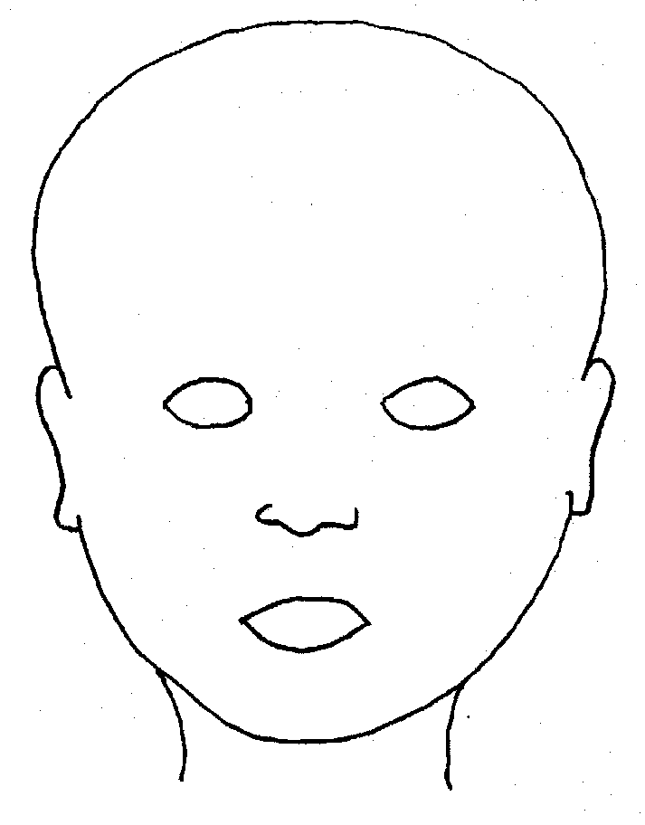 |  | 
FRONT |  | BACK
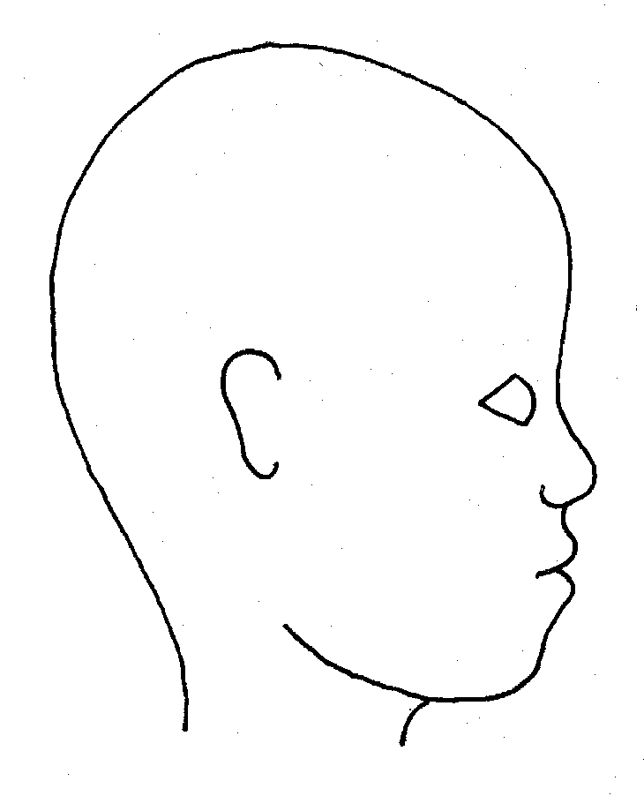 |  | 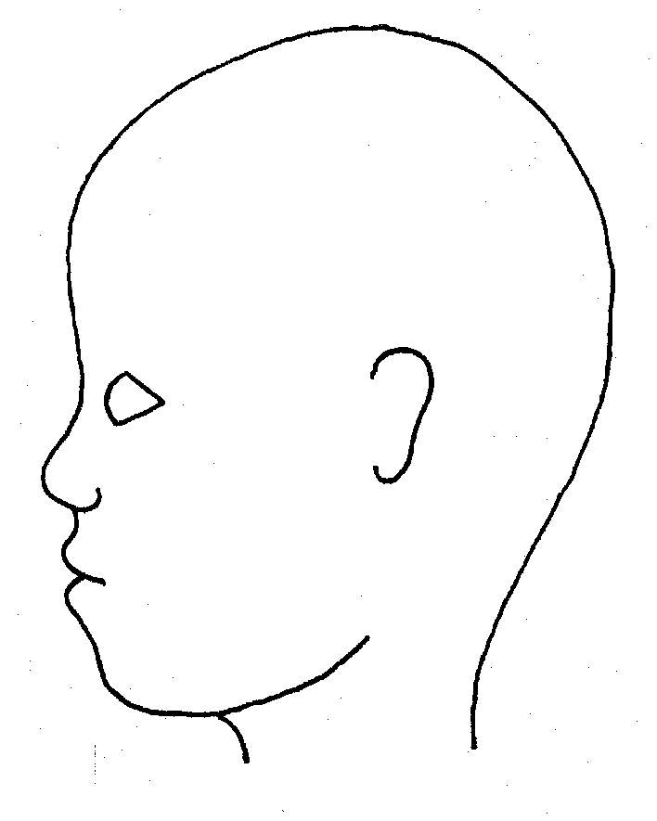
RIGHT |  | LEFT

Name of pupil: |  |  |  |  |  |  | Date and time of observation:
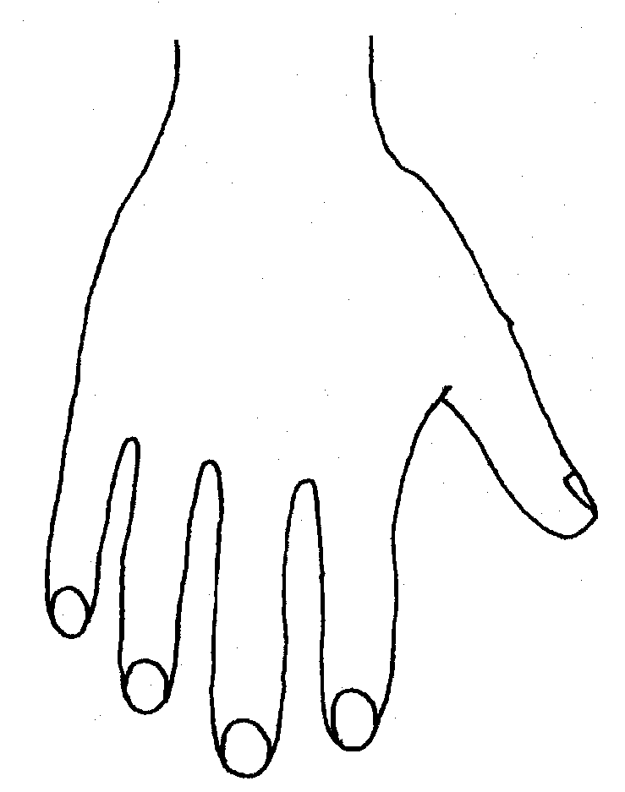 |  |  |  |  |  | 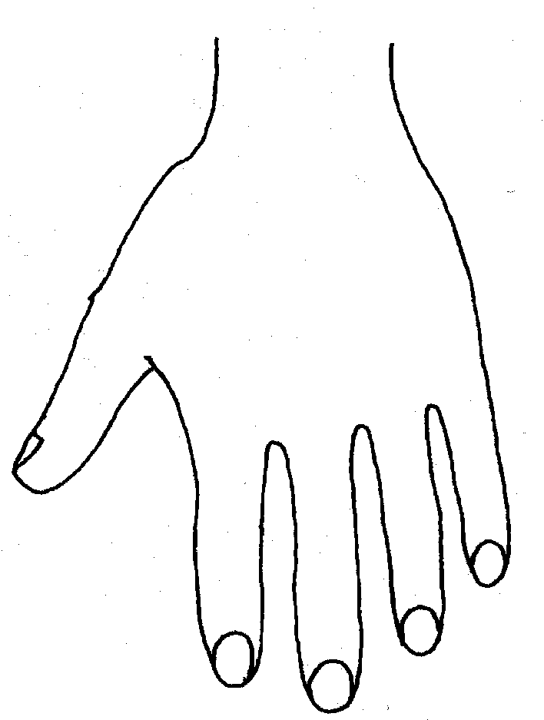
R |  |  |  |  |  | L
BACK
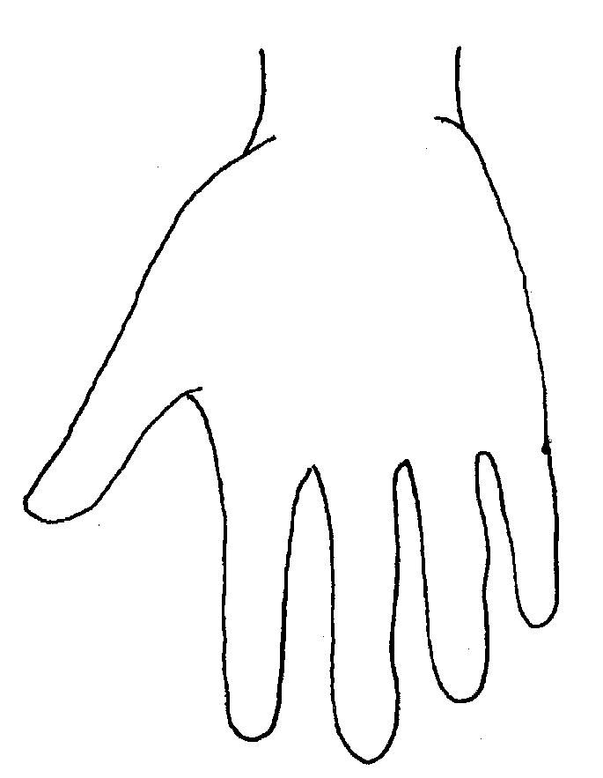 |  |  |  |  |  | 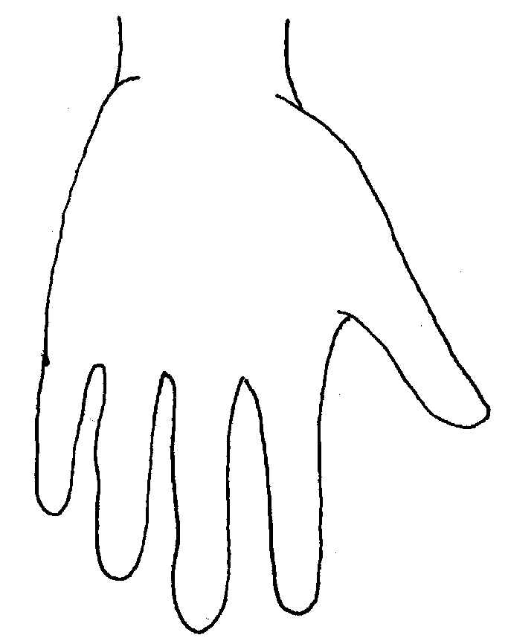
Name of Pupil: |  |  |  |  |  |  | Date and time of observation:
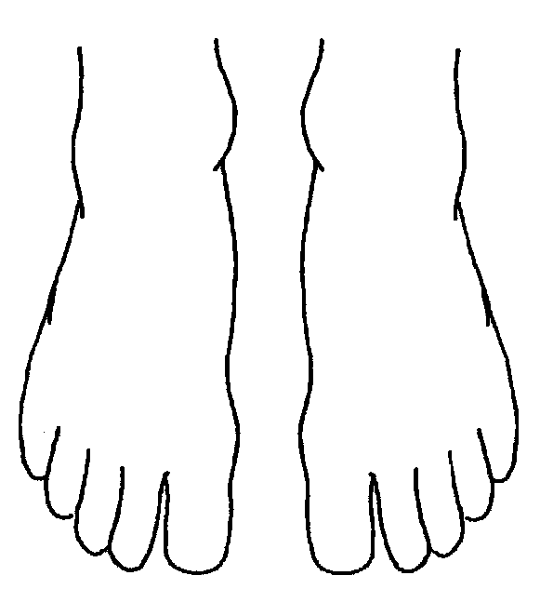 |  |  |  |  | 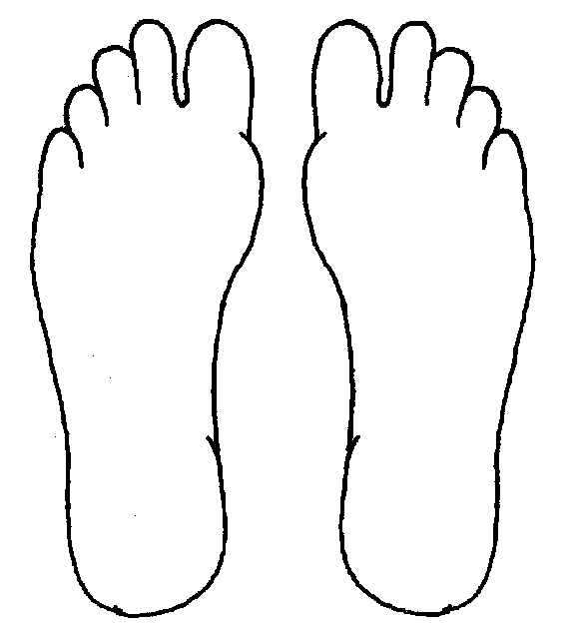
R | TOP |  |  | L | R |  |  | BOTTOM |  |  |  | L
 |  |  |  |  | 
R |  |  |  |  | L
INNER
 |  |  |  |  | 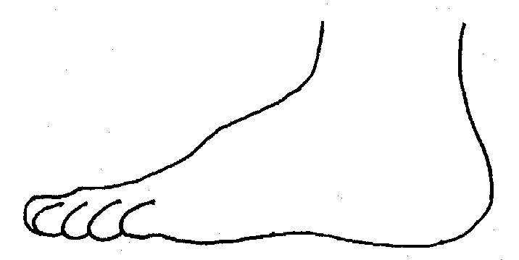
R |  |  |  |  | L
OUTER
Printed Name, Signature and Job title of staff:

Appendix 6 template to record contact information
Name of Child | DOB Group room | Home Address | Parents/carer contact details | Name of Social worker and contact details | Other Agencies | Type of Plan  LAC  CP  CIN  CAF | Dates of: Conference,  Reviews and Meetings

Appendix 7. MASH Referral form
Guide for threshold and practice | MASH Referral form | Early Help Information

