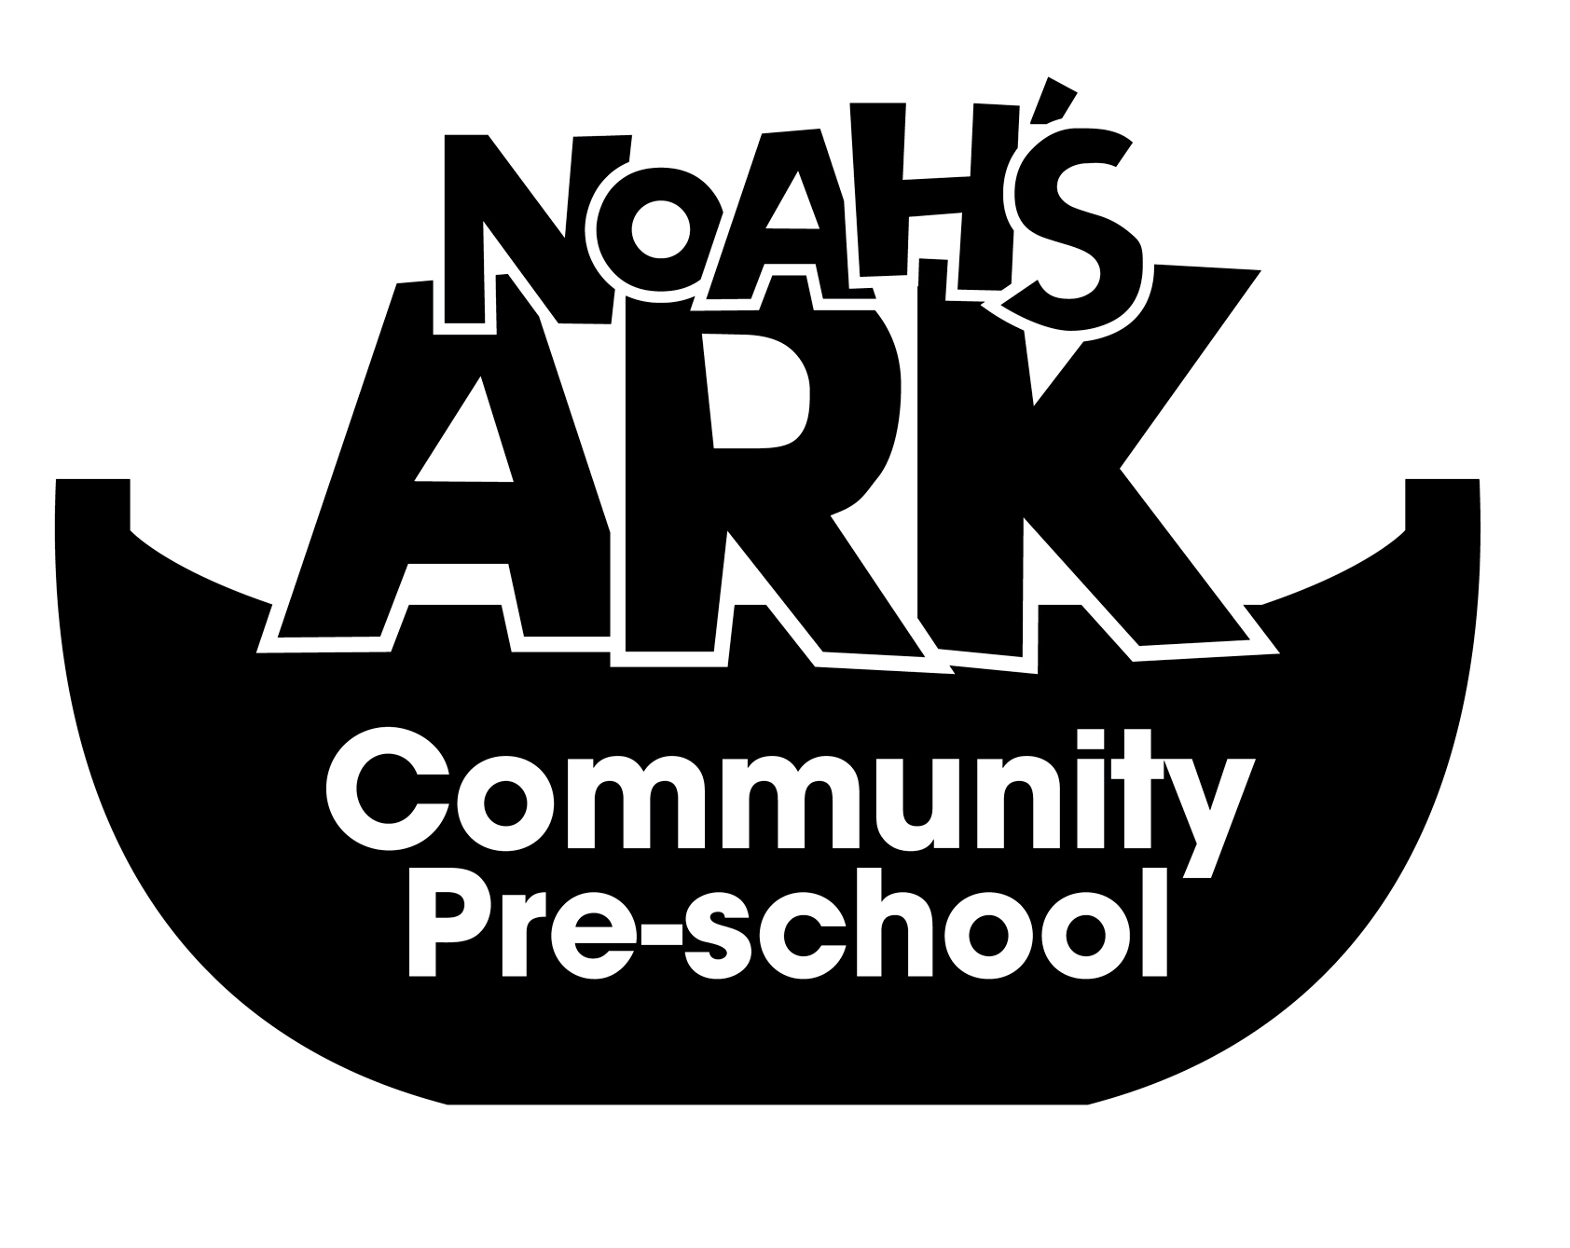

NOAHS ARK COMMUNITY PRE-SCHOOL
8. COMPLAINTS POLICY & PROCEDURE
(September 2023)
The Pre-School believes that children and parents are entitled to expect courtesy and prompt, careful attention to their needs and wishes. We welcome suggestions on how to improve our setting and will give prompt and serious attention to any concerns about the running of the Pre-School. We anticipate that most concerns will be resolved quickly by an informal approach to the appropriate member of staff. If this does not achieve the desired result, we have a set of procedures for dealing with concerns. We aim to bring all concerns about the running of our Pre-School to a satisfactory conclusion for all the parties involved.

Making a complaint

Stage 1
Any parent who has a concern about an aspect of the Pre-School’s Provision should initially speak to the Pre-School leader. Most complaints should be resolved amicably and informally at this stage.

Stage 2
If this does not have a satisfactory outcome or the problem recurs, then the concern should be put in writing to the Pre-School leader. For parents not comfortable with making written complaints there is a template form for recording complaints in the summary complaints record, held by the Pre-School. The form will be completed with the Pre-School Manager and signed by the parent.
The Pre-School stores written complaints in the child’s personal file. However, if the complaint involves a detailed investigation, the Pre-School leader will store all information relating to the investigation in a separate file designated for this complaint.
When the investigation into the complaint is completed, the Pre-School leader will meet with the parent to discuss the outcome.
Parents will be informed of the outcome, in writing, within 28 days of making the complaint.
When the complaint is resolved at this stage, the summative points will be logged in the summary complaints record.

Stage 3
If the parent is not satisfied with the outcome of the investigation, then a meeting will be made with the Pre-School leader. The parent should have a friend or partner present if required and the Pre-School leader should have the support of the Director.
An agreed written record of the discussion is made as well as any decision or action to take as a result. All of the parties present at the meeting should sign the record and receive a copy of it.
This signed record signifies that the procedure has concluded. When the complaint is resolved at this stage, the summative points are logged in the summary complaints record.

Stage 4
If at the stage three meeting the parent and the Pre-School cannot reach an agreement, an external mediator is invited to help settle the complaint. This person should be acceptable to both parties, listen to both sides and offer advice. A mediator has no legal powers but can help to define the problem, review the action so far and suggest further ways in which it might be resolved.
Staff or volunteers within the Pre-School Learning Alliance are appropriate persons to be invited to act as mediators.
The mediator keeps all discussions confidential. S/he can hold separate meetings with the Pre-School leader and Director and the parent, if this is decided to be helpful. The mediator keeps an agreed written record of any meetings that are held and of any advice that s/he gives.

Stage 5
When the mediator has concluded his/her investigations, a final meeting between the Pre-School, Director and parent is held. The purpose of this meeting is to reach a decision on the action to be taken to deal with the complaint. The mediator’s advice is used to reach this conclusion. The mediator is present at the meeting if all parties think that this will help a decision to be reached.
A record of this meeting, including the decision on the action to be taken, is made. Everyone present at the meeting signs the record and receives a copy of it. This signed record signifies that the procedure has concluded.
The role of the Office for Standards in Education, EarlyYears Directorate (OFSTED) and the local Safeguarding Children Board.
Parents may approach OFSTED directly at any stage of this complaints procedure. In addition, where there seems to be a possible breach of the setting’s registration requirements, it is essential to involve OFSTED as the registering and inspection body with a duty to ensure the Welfare Requirements of the Early Years Foundation Stage are adhered to.
The contact details for OFSTED with regard to a complaint is:
By Post: OFSTED, Picadilly Gate, Store Street, Manchester, M1 2WD
Tel no: 0300 1231231
Email: enquiries@ofsted.gov.uk
These details are displayed on the Pre-School notice board.
If a child appears to be at risk, our setting follows the procedures of the Local Safeguarding Children Board in our local authority.
In these cases, both the parent and the Pre-School are informed and the Pre-School leader works with Ofsted or the Local Safeguarding Children Board to ensure a proper investigation of the complaint, followed by appropriate action.
Records of complaints are kept by the Pre-school for 3 years.
This policy is reviewed annually
Date: 3rd September 2023
Signed on behalf of the Pre-School:
Position: Manager

