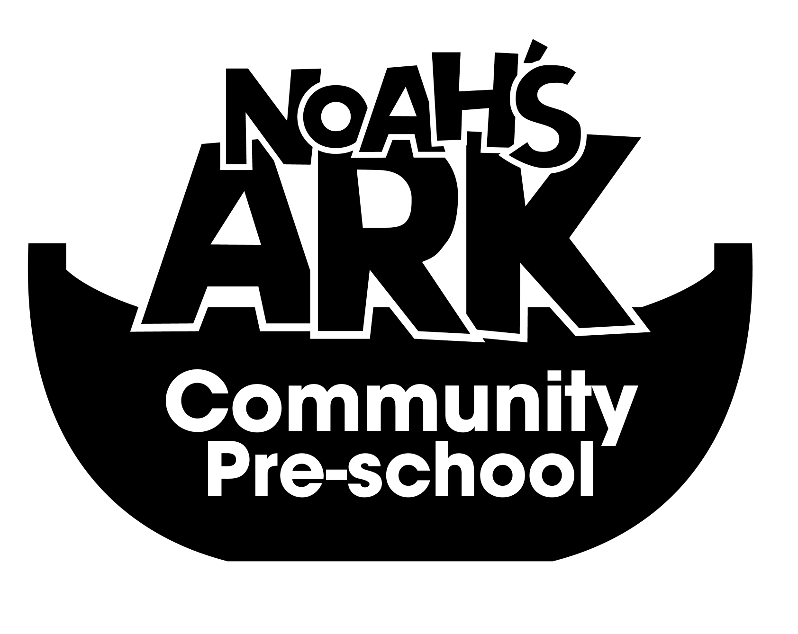

NOAHS ARK COMMUNITY PRE-SCHOOL

10.CURRICULUM POLICY

( 3rd September 2024)

The Pre-School provides a curriculum for 2-5 year olds as outlined in the Early Years Foundation Stage curriculum (2021).

‘The Early Years Foundation Stage (EYFS) sets the standards that all early years providers must meet to ensure that children learn and develop well and are kept healthy and safe. It promotes teaching and learning to ensure children’s ‘school readiness’ and gives children the broad range of knowledge and skills that provide the right foundation for good future progress through school and life.

The EYFS seeks to provide:
• Quality and consistency in all early years settings, so that every child makes good progress and no child gets left behind;
• A secure foundation through learning and development opportunities which are planned around the needs and interests of each individual child and are assessed and reviewed regularly;
• Partnership working between practitioners and with parents and/or carers;
• Quality of opportunity and anti-discriminatory practice, ensuring that every child is included and supported.

(Statutory Framework for the Early Years Foundation Stage 2021)

The content of the curriculum is defined by the areas of learning and development

There are seven areas of learning and development that must shape educational programmes in early years settings. All areas of learning and development are important and inter-connected. Three areas are particularly crucial for igniting children’s curiosity and enthusiasm for learning, and for building their capacity to learn, form relationships and thrive. These three areas, the prime areas, are:
Communication and language
Physical development
Personal, social and emotional development

Providers must also support children in four specific areas, through which the three prime areas are strengthened and applied. The specific areas are:
Literacy
Mathematics
Understanding the world
Expressive arts and design.
(Statutory Framework for the Early Years Foundation Stage March 2021)

The curriculum is organised in the following ways.

Long Term Planning/mission statement, reviewed annually by the staff and committee.
This will look at the overall goals and aims of the group, focusing on each of the areas of learning in the Government’s Foundation Stage.

Medium Term Planning, organised, planned and evaluated by staff half-termly.

Short Term Planning. This is organised and planned weekly by staff at a planning meeting. This planning is defined by regular observations of the children by their key-worker. This enables staff to detail materials and methods to be used in each activity, that will meet the needs of individual children and the group as a whole.

The pre-school will deliver the curriculum according to the needs of each child through, observation, record-keeping, key-working and partnership with parents and carers.
The medium and short term plans will always be displayed on the main planning board.

A regular newsletter with details of the theme will be distributed. It will also give suggestions for supporting the children’s learning at home.

The Pre-school is committed to training, staff, volunteers and students in curriculum matters.

This policy is reviewed annually
3rd September 2024

Signed on behalf of the Pre-School:
Position: Manager

